BSPM Bank

## San Jose State University

## CMPE-202 : Software Systems Engineering

Professor: Gopinath Vinod

ISA: Mahenaz Sayyed

Group Name: TECHIE TRIBE

Team Members: [Bhavya Tetali](https://www.linkedin.com/in/bhavyatetali3/), Manjiri Kadam, [Pranjali Kotgire](https://www.linkedin.com/in/pranjali-kotgire/), [Supriya Meduri](https://www.linkedin.com/in/supriya-meduri-a846377a/)

* **Welcome page**: Customer/Admin can signup or login

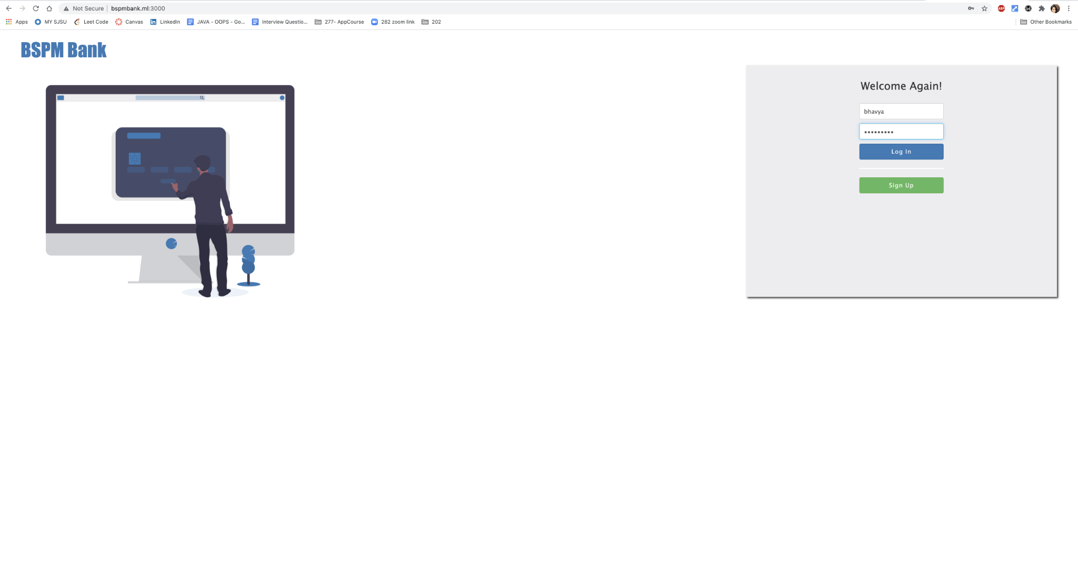

* New Customer Signup

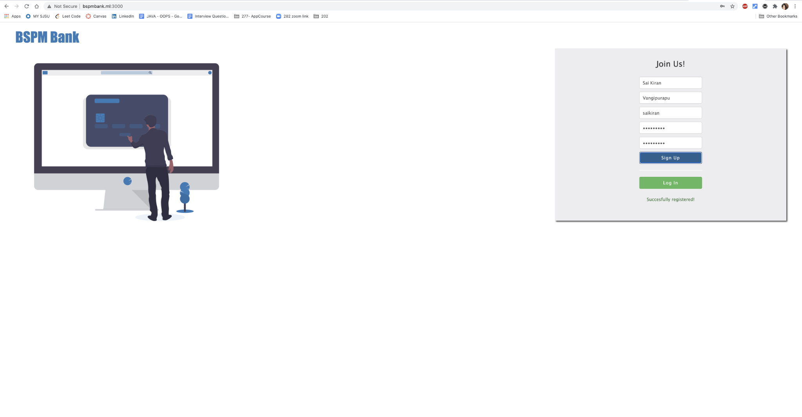

* Customer Login

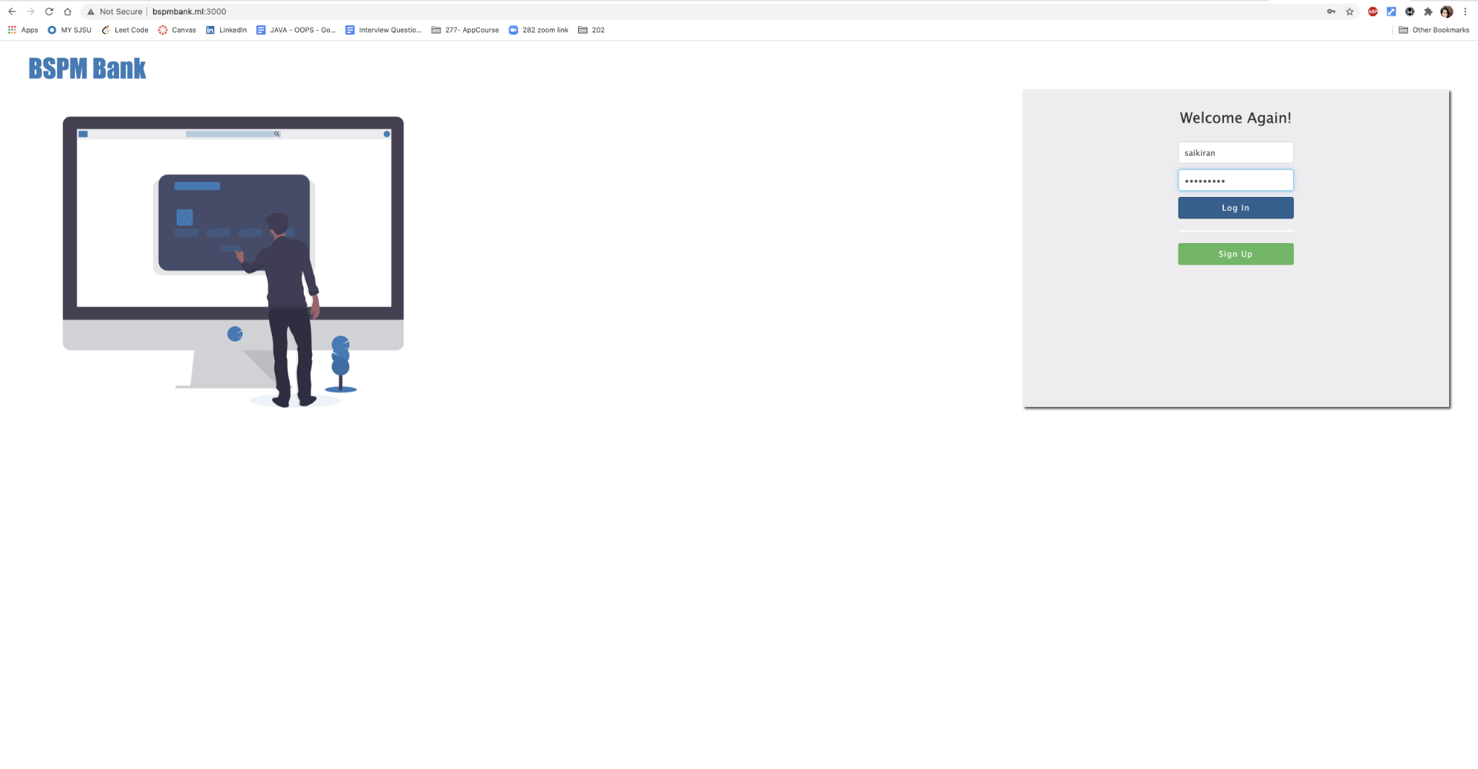

* Customer dashboard

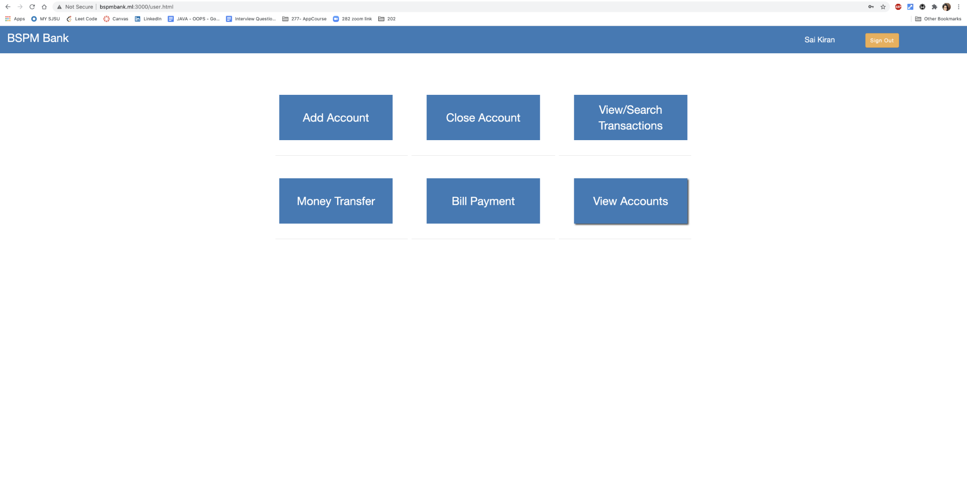

* Customer can add account, either savings or checking account

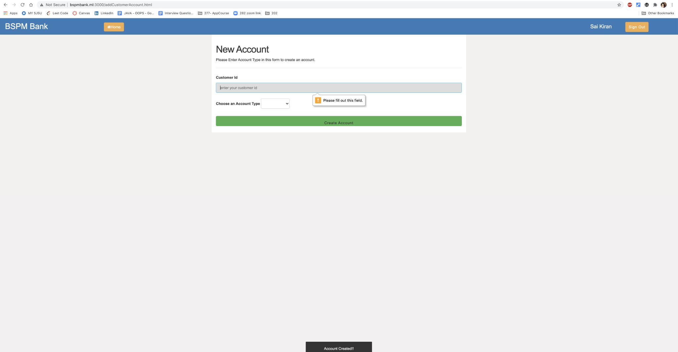

* Once customer adds account , Under View Account title we can see the newly added account details

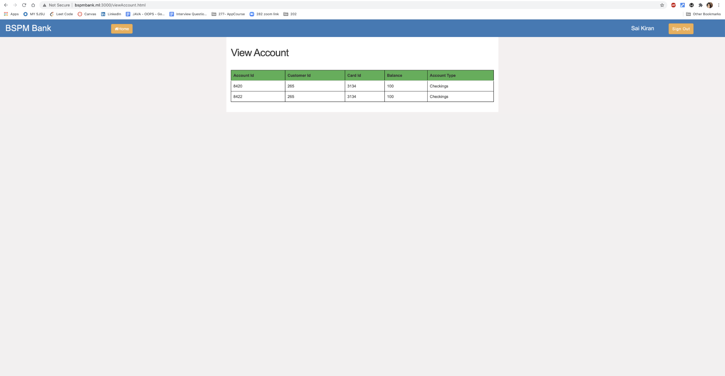

* **Internal Transfer** - Customers can transfer money internally within the bank, here customers are not expected to enter the routing number since its an internal transfer.

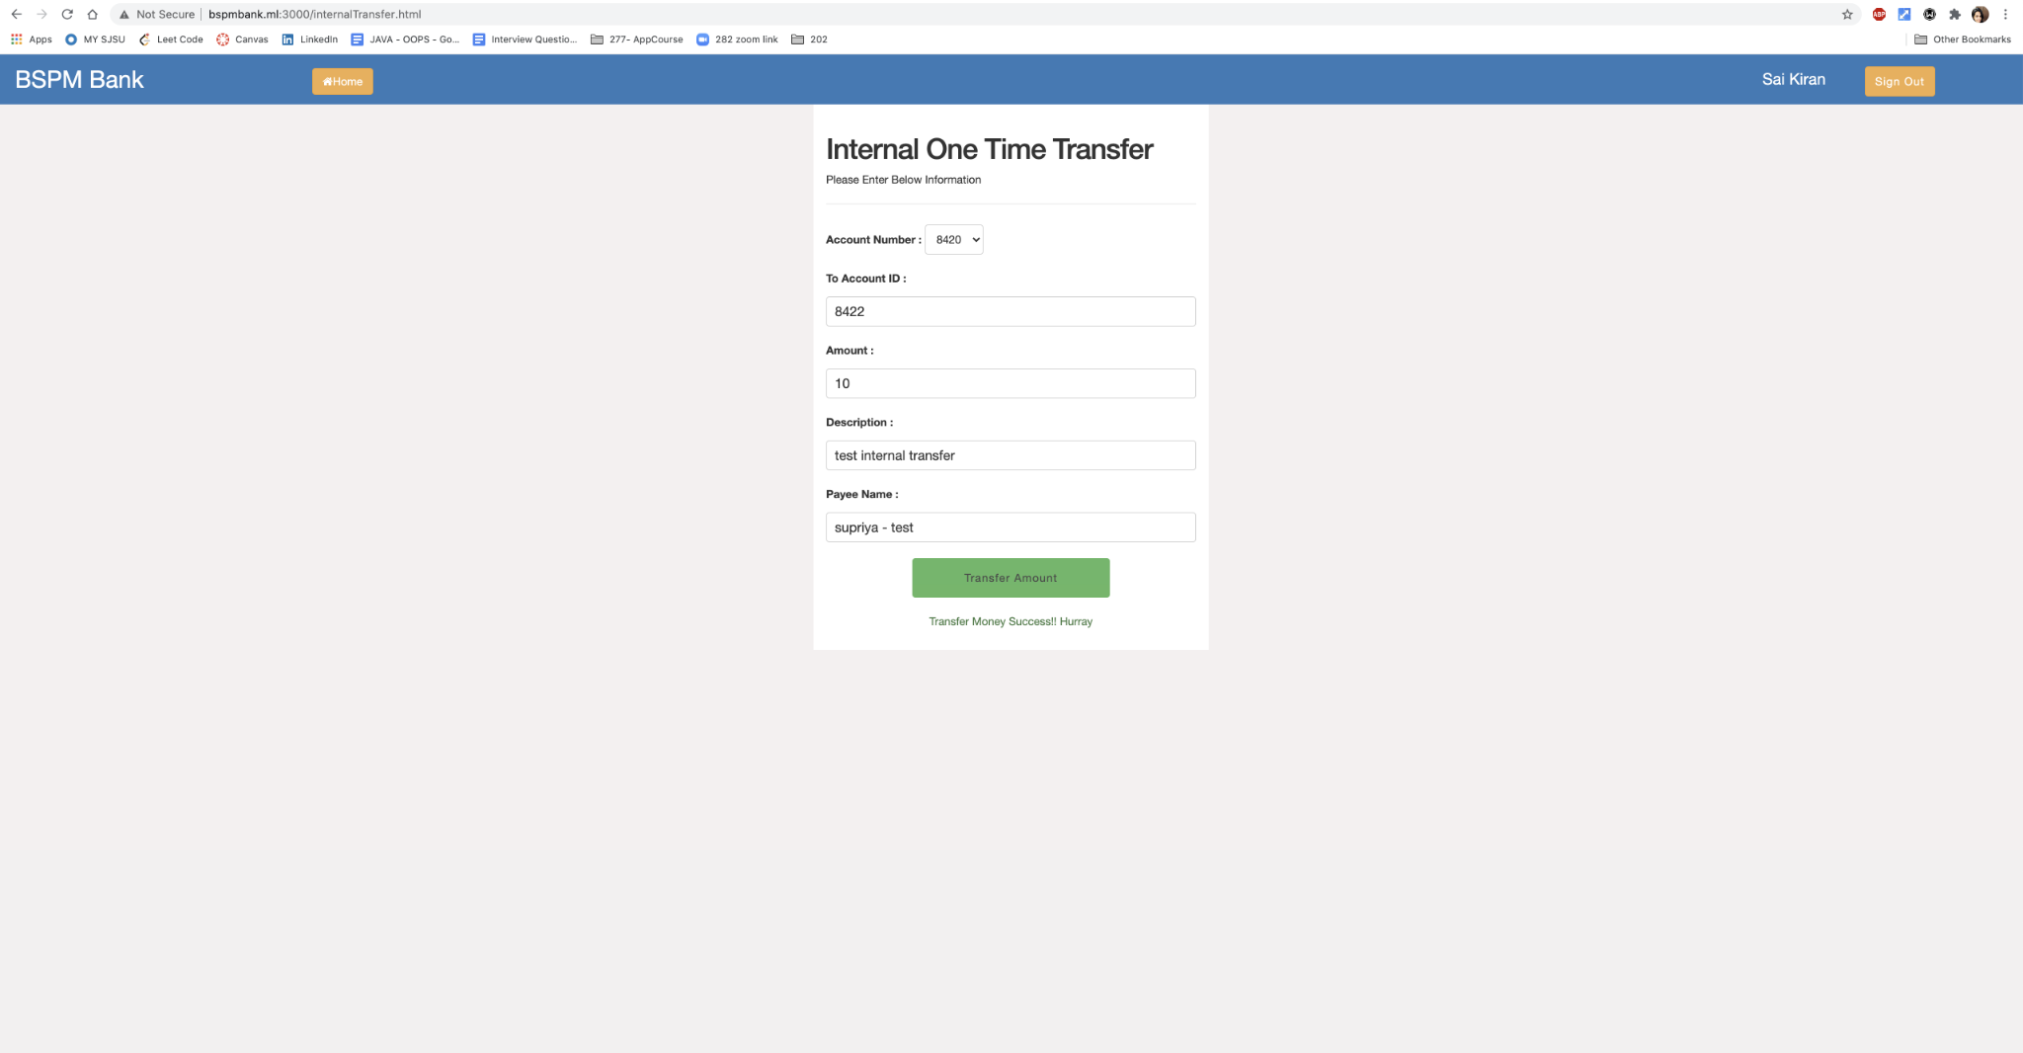

* Account details after internal transfer

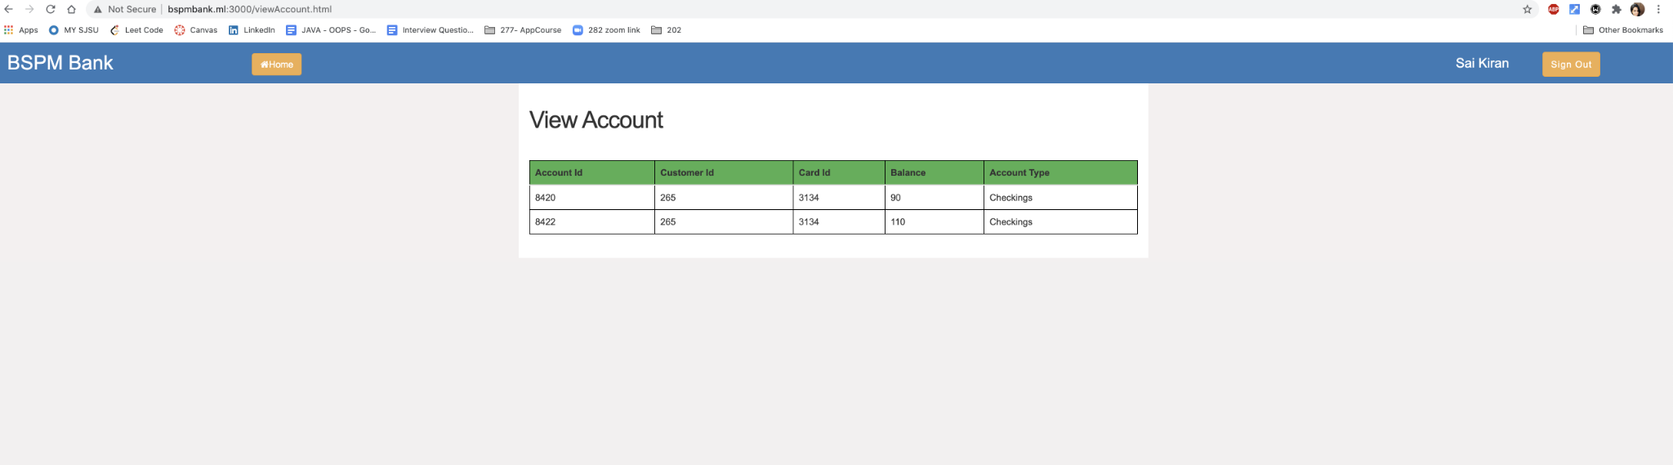

* When a customer tries to transfer to an external account using internal transfer link, an error is thrown.

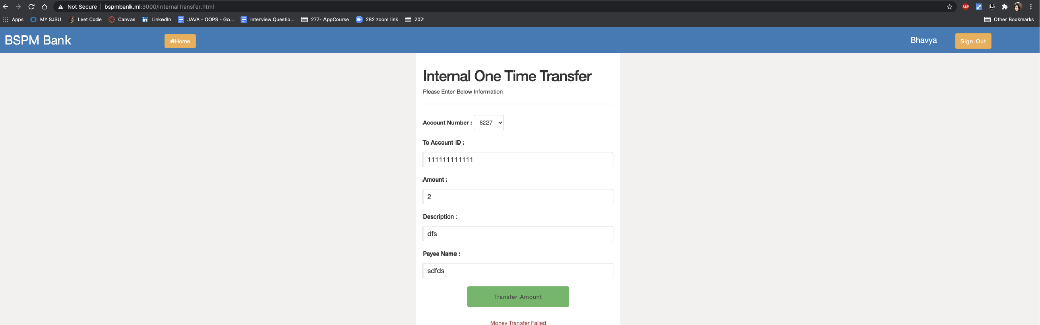

* **External Transfer** - Customers can transfer money externally out of bank, here customers are expected to enter the routing number since its an external transfer.

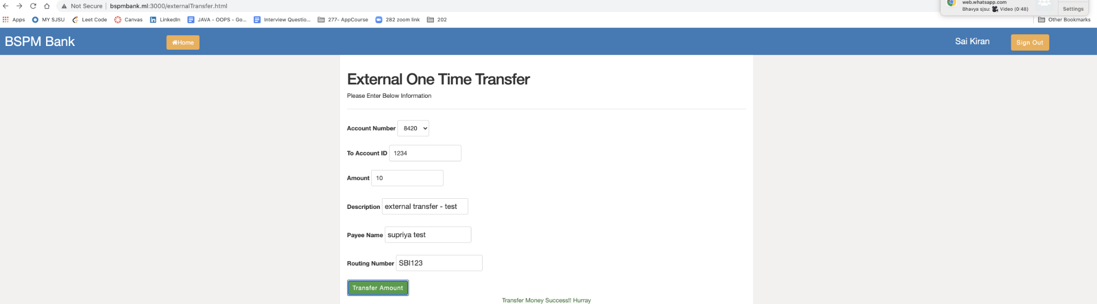

* **View Transactions** - Customers can view transactions within a time frame by providing the start date and end date.

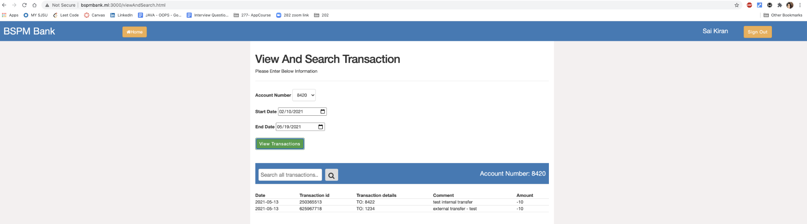

* **Search Transactions-** Customers can search transactions by entering a keyword for a specific transaction

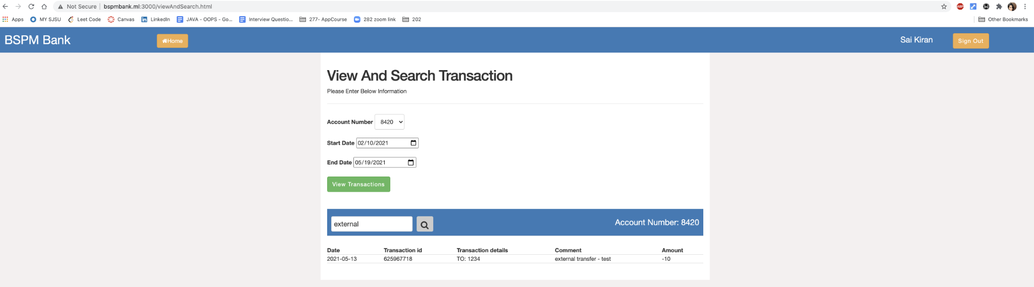

* **Close Account** - Customers can close account here

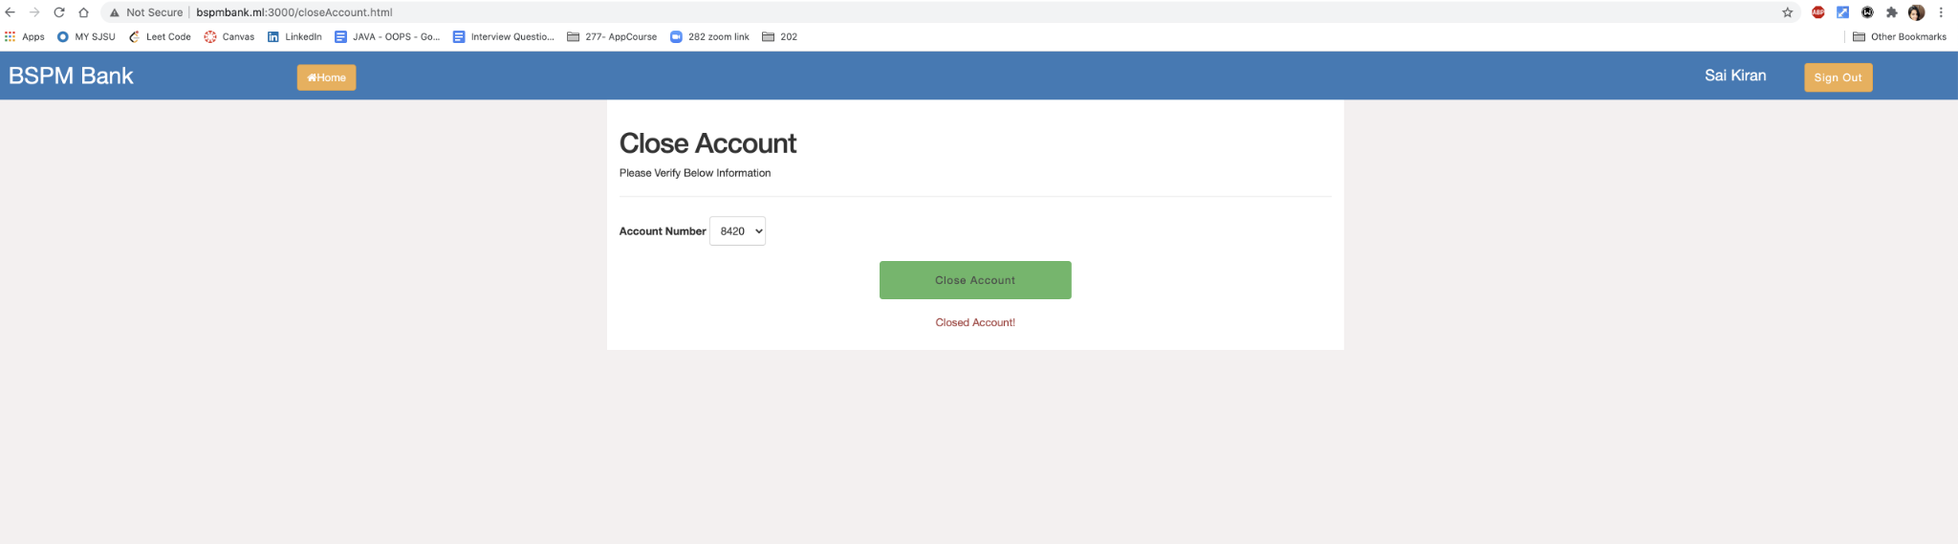

* Closed Account is not shown in the view account section after closing the account.

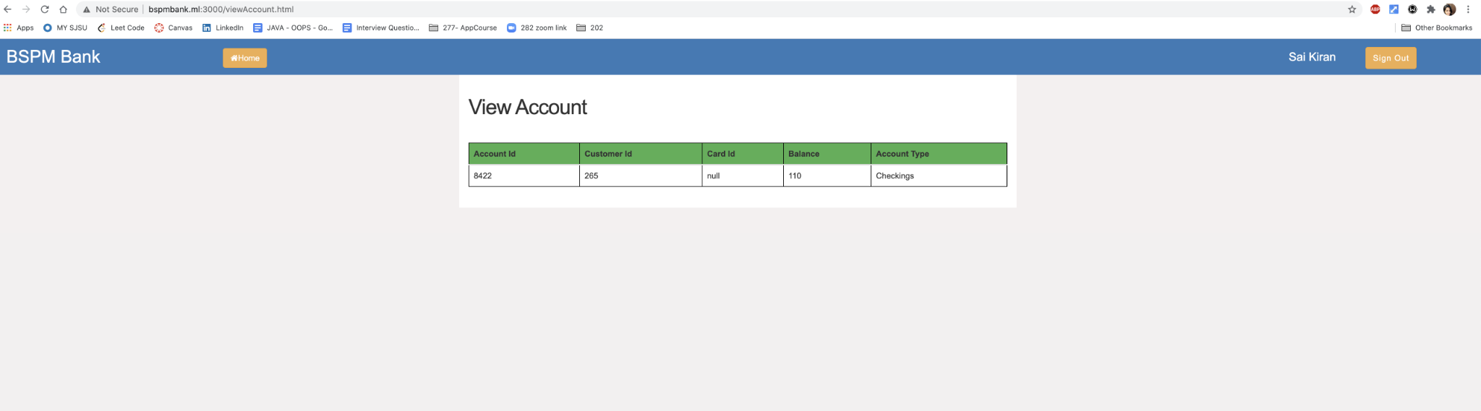

* Bill Payment - One time

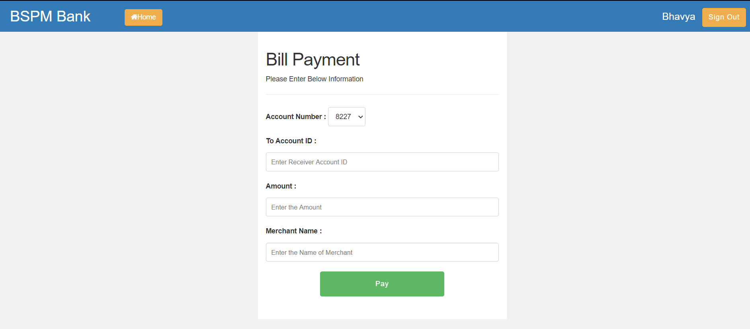

* Bill Payment - Recurring transfer

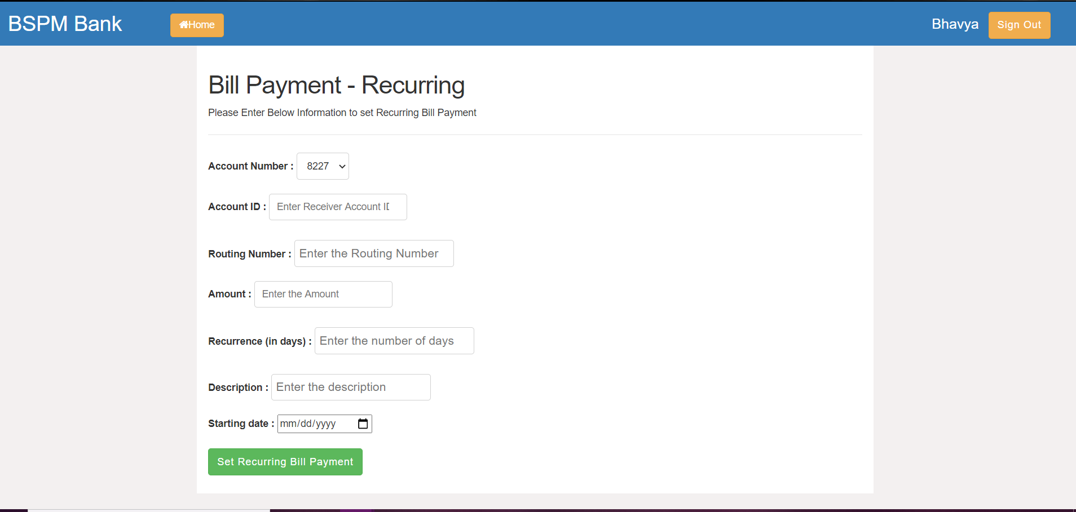

* Internal Transfer - Recurring transfer

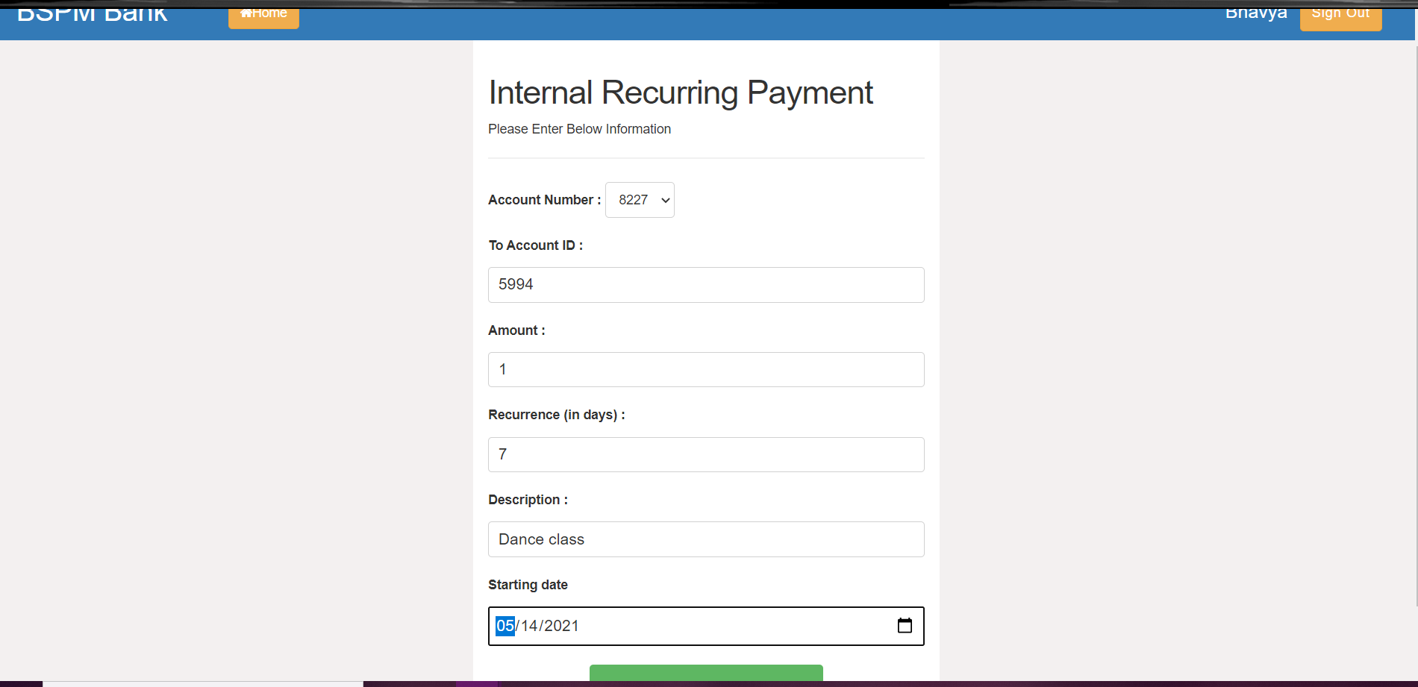

* External Transfer - Recurring transfer

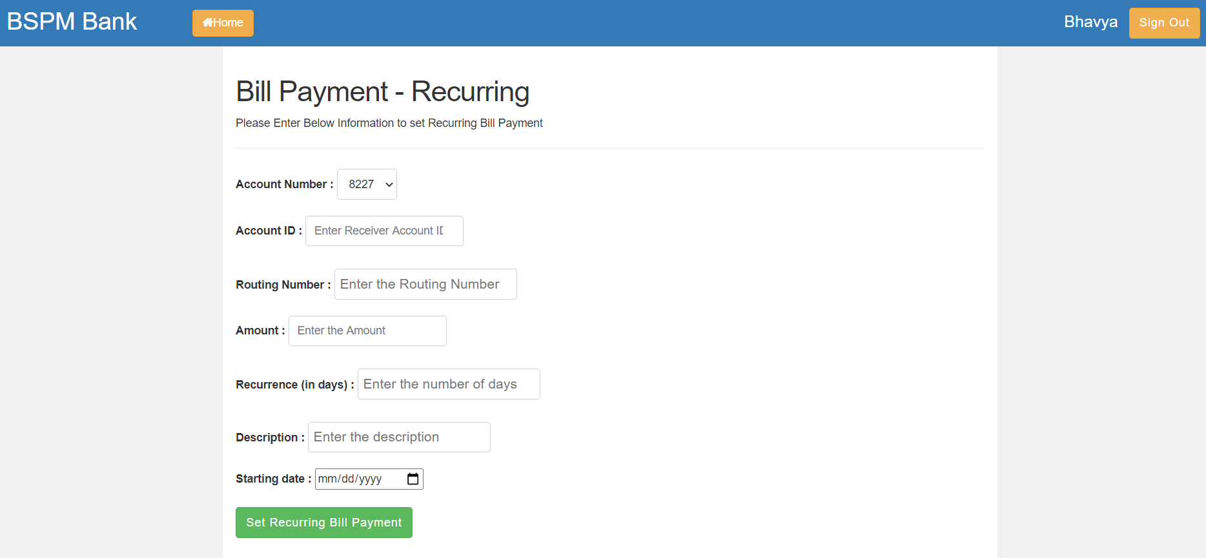

* The same application supports admin login as well.

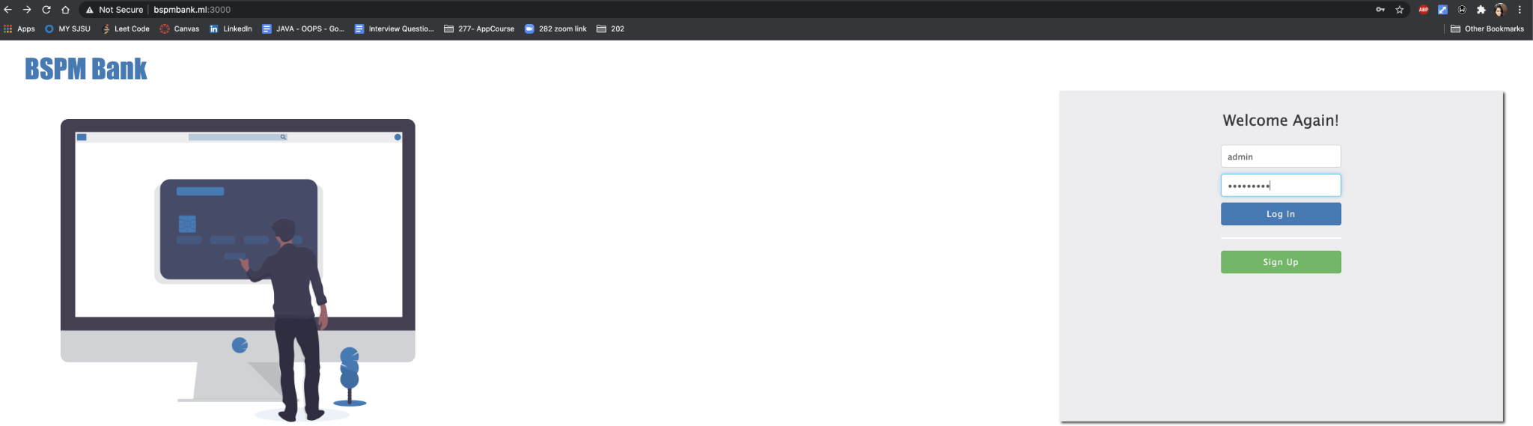

* Admin - Dashboard

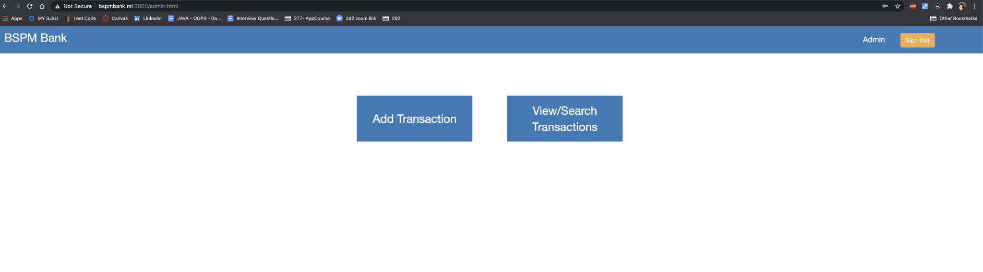

* **Add Transaction**- Admin can manually add transactions to any account.

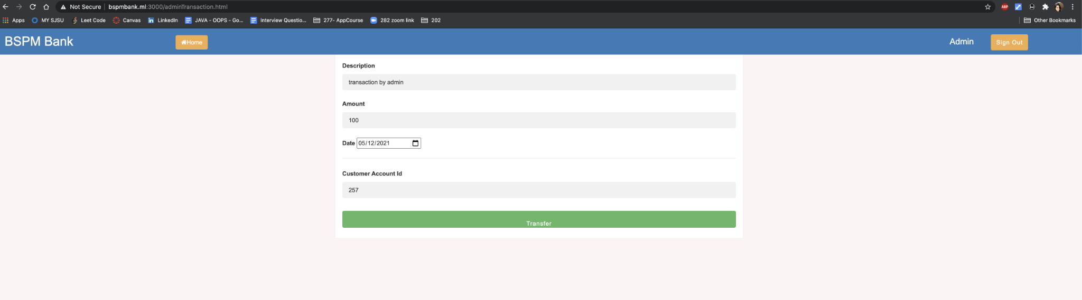

* **View Transaction** - Admin can view the transactions for all the accounts in the bank within a given time frame by providing the start date and end date

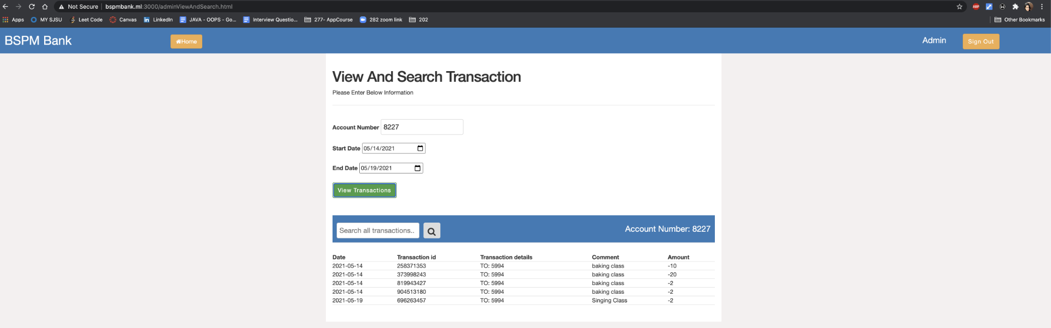

* **Search Transaction** - Admin can search any particular transaction by providing the keyword for search

